Aesthetic ProTools

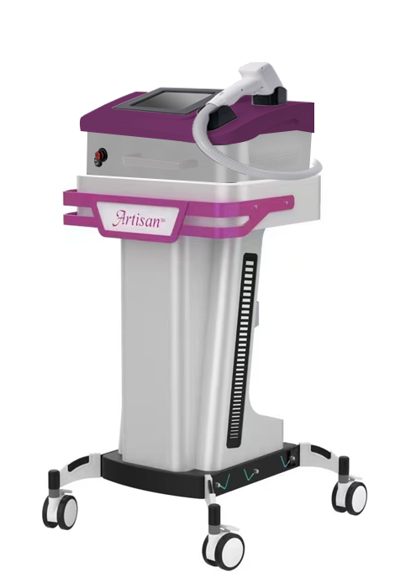

**User’s Manual**

**Aesthetic Diode Laser System**

|  |  |
| --- | --- |
| **1. Model:** | Vader 808: 808nm, 600W |
| **2. Serial Number:** |  |
| **3. Software Version:** | LOAD-B 1.0.006 |
| **4. Date of Sale:** |  |
| **5. Manufacturer:** | Aesthetic ProTools, Inc.  8969 East Talking Stick Way  Suite C-5  Scottsdale, AZ USA 85250 Phone: 480-291-5880  www.AestheticProTools.com • [info@Aestheticprotools.com](mailto:info@artisanprotools.com) |

***CAUTION: USFDA (USA) restricts this device to sale by or on the order of a physician.***

**WARNING!**

**This laser device is sold for use on humans only.**

This document or its contents may not be provided to third parties or copied without express written permission from the manufacturer. All rights, including copyright protection, are reserved. © Aesthetic ProTools, Inc.

**TABLE OF CONTENTS**

1. INTRODUCTION 5-8
   1. Corporate Contact Information 5
   2. Copyright Notice 5
   3. Overview of Conventions Used in Manual 6
   4. Overview of General Precautions 7
   5. Overview of General Safety Warnings 8
   6. Recommendation of Laser Safety Officer 8
2. THEORY AND TECHNICAL INFORMATION 9
3. TRANSPORTATION AND STORAGE CONDITIONS 10
   1. Packaging Information 10
   2. Transportation and Storage Conditions 10
4. USAGE PREREQUISITES 11-12
   1. Safety Information 11
   2. Treatment Room Requirements 11
      1. Labeling The Entrance 11
      2. Laser Protection of Windows 11
      3. Protection Against Highly Reflective Surfaces 11
   3. Environmental Protection 11
   4. Unpacking 12
5. SAFETY 13-22
   1. Laser Classification 13
      1. Class IV Lasers and Laser Systems 13
   2. Laser Safety 14
      1. Safety Program 14
      2. Laser Safety Officer 14
      3. Eye Protection 14
      4. Required Users of Safety Goggles: 14
      5. Importance of Wearing Safety Goggles 14
      6. Safety Goggles 15
      7. Using Safety Goggles Correctly 15
      8. Laser Safety Warning Signs 16
   3. Environmental and Electrical 16
   4. Federal Regulation Compliance 16
   5. Laser Safety Supervision 16
   6. Warnings 17
   7. Precautions 18
   8. Labels and Symbols 19
   9. Safety Features on Device 21
   10. Laser Safety Checklist 22
   11. Sources for Additional Information and Assistance on Laser Safety 22
6. CLINICAL INDICATIONS 23-26

6a Laser Hair Reduction Protocol 23

6b Collagen Synthesis Protocol 25

1. PRODUCT DESCRIPTION 27-32
   1. Specifications 27
   2. General Overview 28
   3. Front 29
      1. Casters 29
      2. Emergency Stop 29
      3. Alarm Indicator 29
      4. Laser Emissions Indicator 29
      5. Power Indicator 29
      6. Handpiece Holder 29
      7. Color Touch Screen 30
      8. Encode Icons 30
      9. Hand Piece 31
      10. Hand Piece Holder 31
   4. Rear Panel 32
2. OPERATING THE LASER DEVICE 33-41
   1. Introduction 33
   2. Starting the Laser Device 34
   3. Main Menu Screen 35
   4. Setting Laser Operations 36
      1. Set Laser Output Power 36
      2. Select Laser Pulse Width 36
      3. Set Laser Energy 37
      4. Reset Shot Count 38
      5. Standby and Ready 39
      6. Menu Interface 40
         1. Settings 40
3. TROUBLESHOOTING 42
4. MAINTENANCE 43
   1. Optical Coupler Maintenance and Cleaning 43
   2. Main Unit Maintenance 43
5. SERVICE 44
6. LASER THEORY AND LASER TERMS 45-48
   1. Laser Theory 45
   2. Laser Terms 46
7. WARRANTY CERTIFICATE 49
8. WARRANTY REGISTRATION 50
9. APT PRODUCT RETURNS & REPAIRS 51

# INTRODUCTION

### Corporate Contact Information

Thank you for choosing the APT Artisan VADER Laser System.

The VADER 808 is a Class IV laser. Care is required to avoid hazards or injuries. Please read this manual carefully before operating. If you have further questions not answered in this manual regarding safety, application, or operations of the device, please contact your local distributor or:

**Aesthetic ProTools, Inc.**

8969 East Talking Stick Way

Suite C-5

Scottsdale, AZ USA 85250

Phone: 480-291-5880

Web: aestheticprotools.com

Email: [info@Aestheticprotools.com](mailto:info@aspenlasers.com)

### Copyright Notice

The device appearance, control software and other related parts of the Aesthetic ProTools Laser System are protected by copyright with all rights reserved. Attempts at counterfeiting by any company or person will result in a legal liability.

Under copyright laws, this manual cannot be copied in whole or in part without the express written consent of Aesthetic ProTools, Inc. Any permitted copies must carry the same proprietary and copyright notices as were affixed to the original version.

The manual will be updated, from time to time, with the modifications and upgrades to the device.

### Overview of Conventions Used in Manual

Various precautions, warnings, recommendations, and notes are presented throughout this document. Explanations and examples of each follow.

CAUTION!

**Never allow an untrained person to operate this device unless directly supervised by a Certified Laser Technician (CLT) or Supervising Laser Technician (SLT) trained and experienced in use of this device.**

WARNING!

**Never direct the laser beam at anything other than the area to be treated.**

RECOMMENDATION

**Designate at least one person at each facility that utilizes this device as laser safety officer (LSO), responsible for providing training on all operating and safety procedures.**

NOTE

**Focusing optics are magnetically attached and fragile. Exercise extreme care in removal, storage and replacement.**

### Overview of General Precautions

* Never allow untrained personnel to operate this advice unless directly supervised by a Certified Laser Technician (CLT) or Supervising Laser Technician (SLT) experienced with this device.
* The protective eyewear supplied with this device has an optical density rating =/> 4OD in the 808 nm wavelength region. All personnel present during any device operation must wear this eyewear at all times the device is active.

Contact Aesthetic ProTools, Inc. at 1-480-291-5880 to purchase additional sets of protective eyewear for this device.

* Select a secure, properly equipped, and well-ventilated location in which to install and operate the laser.
* Place ANSI Z136.1 approved “Laser Safety” signs at entrances into the area where people will use the Artisan VADER Laser System.
* Always put the laser in Standby mode or switch the device off prior to adjusting or preparing the handpiece optics.
* Never leave this device in the READY mode unattended. See the STANDBY to READY Mode in the USER’s section of this manual.
* Remove the key from the device’s key switch when not in use to prevent unauthorized and/or unqualified use of the device.
* Turn the device off before relocating equipment even in the same vicinity.
* Never press the foot panel without first verifying the safe orientation and proper positioning of the handpiece and ensuring compliance to all applicable safety precautions.
* During any laser procedure, do not allow any nonessential personnel into the treatment area.
* Never allow untrained personnel to operate this device unless directly supervised by a Certified Laser Technician (CLT) or SLT experienced with this device.
* ALWAYS clean the interior optic face before inserting into the optics receiver port. Contaminated optic surfaces could result in damage to the unit.

### Overview of General Safety Warnings

* This laser device is intended for human uses only!
* This laser device produces 808-nanometer (808 nm) near infrared laser energy that is invisible and can be an extreme hazard to the eyes of any living being. Irreparable corneal and/or retinal damage may occur if a person exposes one or both eyes to direct and indirect (reflected) laser energy.
* Improper use of system controls or performance of procedures other than those specified in this manual may result in hazardous radiation exposure.
* Failure to comply with all safety instructions and warnings may expose all participants to harmful levels of laser radiation and/or dangerous levels of electrical current.
* NEVER DIRECT THE LASER BEAM AT ANYTHING OTHER THAN THE AREA TO BE TREATED.
* NEVER allow any person to look directly into the diode housing or output optic connected to an active laser device - WITH or WITHOUT wearing laser emission protective eyewear.
* DO NOT allow any reflective object to fall into or obstruct the path of the laser energy produced by this device. Scattered or reflected laser energy can cause severe damage to eyes and skin. The operator, all assistants, and the patient must remove all reflective objects (such as rings, metal watchbands, and jewelry) prior to treatment with this device.
* THERE ARE NO USER-SERVICEABLE COMPONENTS inside this laser device. DO NOT attempt to gain access to any internal device component. Doing so may cause serious and/or irreversible injury.
* DO NOT remove protective eyewear until the operator returns the laser device to Standby mode. To do this, the operator releases the foot switch, touches the STANDBY screen button on the display panel, and visually observes the laser device returning to STANDBY mode.
* AVOID THE USE of flammable anesthetics or oxidizing gases such as nitrous oxide (N2O) and oxygen. The high temperatures produced in normal use of the laser equipment may ignite some material, for example cotton or wool, when saturated with oxygen. Solvents or adhesives and flammable solutions used for cleaning and disinfecting should be allowed to evaporate completely before the laser equipment is used. Attention should also be drawn to the danger of ignition of endogenous gases.

If the laser fails to operate properly, immediately contact Aesthetic ProTools, Inc. Service personnel at 1-480-291-5880.

### 1.6. Recommendation of Laser Safety Officer

Designate at least one person at each facility that utilizes this device as Laser Safety Officer, LSO, responsible for providing safety training and routine inspections on all laser equipment and of the operating facility. The LSO is to be responsible for adherence to all industry accepted safety procedures, the associated documentation and record keeping.

Definition of the responsibilities of an LSO are to be found at the American National standards institute, ANSI Z- 136.1: Safe Use of Lasers or in the IMAj Institute Laser Safety Officer training manual.

# THEORY AND TECHNICAL INFORMATION

Diode lasers use a semiconductor in the working design. A diode consists of an active medium material, excitation source, a control system, and power source. An Artisan VADER is a vertical stack, or array, of rectangular diodes combining their individual output into a combined output. Each diode shares a cooling and power system with the adjacent diode creating a uniform operating environment. This arrangement allows for a larger output from the diode assembly than is customary. The higher output allows for modifications of treatment routines allowing for a greater efficiency based on better cooling, multiple delivery diode units, and unified balanced energy inputs to the diodes.

The Artisan VADER diode laser used in this unit is a **V**ertical **A**rray **D**iode **E**nergy **R**adiator (VADER) bar. This VADER assembly output energy has an energy wavelength of 808nm. VADER features a compact structure, remarkably high efficiency, and a long use lifetime. The output energy from the VADER is divergent in character. With the Aesthetic ProTools, Inc.’s unique optical coupling technology, the laser Energy can be efficiently captured at the Artisan VADER output source and delivered directly to the Client’s skin. Elimination of multiple coupling optics, fiber optics and focusing optics improves the efficiency of the design.

The Artisan VADER diode is rated for **200,000,000** shots. This is expected to reduce your cost of operation by reducing repair expenses and downtime.

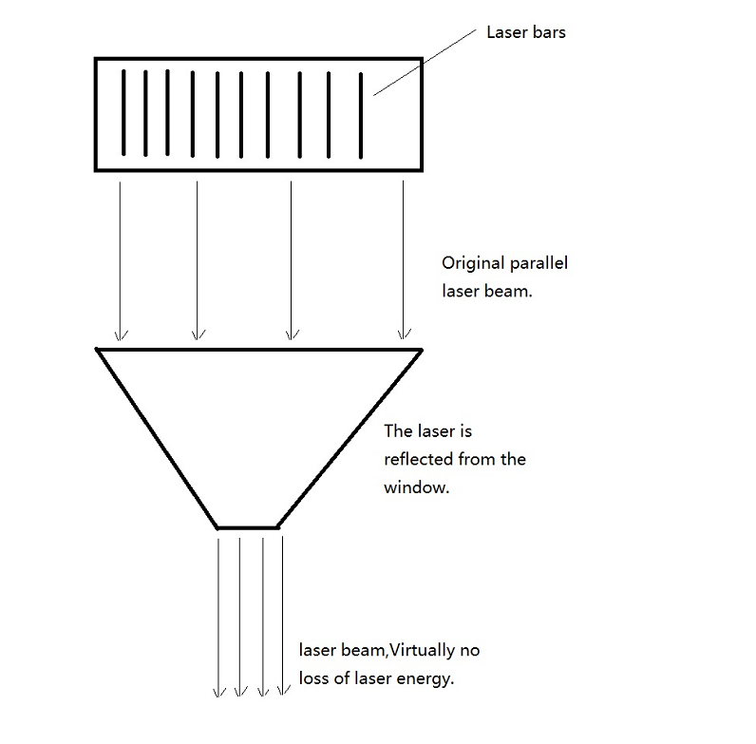



Features and Benefits

The design of the APT VADER creates many efficiencies when compared to traditional hair removal lasers.

**FEATURES:**

**Energy Output:** The APT VADER is a 600-watt output laser, most competitive units offer +/- 90watts. 670% better.

**Beam shape:** The APT VADER is a square output. This improves output by 20% because of the square corners. This also reduces the number of impulses required to cover a treatment area.

**Transverse Electromagnetic Modality (TEM):**  The APT VADER is a TEM00 offering even power distribution. Most LHR lasers are TEM10. This difference adds +/- 50% to the treatment efficiency. Only the middle 50% of a TEM10 laser has useful energy where a laser with TEM00 is 100% useful.

**Direct energy transmission:** No fiber optics or mirrors being used in energy delivery is estimated to add 12-15% efficiency.

**Pulse output capability:** The high energy available allows high firing repetition. APT VADER is able to fire 10 times per second. 10Hz.

**Advanced optic design:**

* APT VADER optics attach to the handpiece by magnetic fasteners. Easy to remove and replace and yet very stable during use.
* The high available power enables larger optics with no energy reduction. 12mm x 20mm is available.
* Smart Optics communicate with the handpiece to adjust the software to match their size automatically
* Thermal Electric Cooler (TEC) contact tip chiller
* The Smart Optics cannot be installed incorrectly. Correct orientation and placement is caused by the design, eliminating Technician errors.

**Cooling system:** Comparatively little heat is produced by APT VADER during operation because of the built-in efficiency. To remove what excess heat is produced, a water-cooling system is integrated. The system includes a deionized filtration element to extend the time between service calls. The deionizer filter removes any minerals that may degrade VADER operation.

**Touch Screen:** Control input is completed by touching the display screen. Fitzpatrick Scale based images on the lower left of the screen enable automatic settings adjustment.

**BENEFITS:**

Fewer impulses are needed per treatment because overlapping is not needed.

High firing speeds make treatments quicker.

Each treatment time, often, is reduced by 75%

Lower energy output can be used because of the many efficiency improvements. Typically, 50-60% reduction.

High energy output format allows hair reduction by selective photothermolysis and density absorption leading to up to 40% hair reduction per treatment. This reduces the treatment packages needed to 4-6, saving your client money and time.

All hair colors can be treated using density absorption.

High energy output plus planned short quasi-CW output allows all skin colors to be treated.

These features enlarge your potential client list by 5 times as only 20% of people have black hair and white skin.

The rapid firing, hand pressure, rapid hand movement, and the cooling tips reduce client discomfort.

***Faster treatments, fewer treatments, more effective and more reliable, APT VADER is the future. The laser you were waiting for.***

# TRANSPORTATION AND STORAGE

### Packaging Information

##### NOTE: Please keep the original packaging (shipping container), it should be used if you need to return the product to the Service Center for service or repair.

The transportation and storage symbols printed on the outside of the box mean:

|  |  |
| --- | --- |
|  | This end up |
|  | Keep away from moisture |
|  | Do not turn over |
|  | Temperature extremes |
|  | Fragile – handle with care |
|  | Not to be stowed under other cargo |

Artisan VADER should be transported and stored in its original container to reduce the potential for damage. Rough handling during transportation should be avoided.

Avoid any exposure to acid, alkali, or caustic material. Always protect Artisan VADER from direct exposure to sun or rain.

### Transportation and Storage Conditions

Ambient Air: Less than 80% humidity. Temperature: 10°C to 55°C (50° to 131° F)

Atmospheric Pressure: 500hPa to 1060hPa.

# USAGE PREREQUISITES

Every facility or institution utilizing this device is encouraged to adopt an ongoing training and safety program.

### Safety Information

Safety information must be located at all entrances and exits (including windows) where the laser light or laser radiation could escape and contact a person.

### Treatment Room Requirements

The use of a medical Class IV Laser requires warnings on the unit itself and clear markings at the entrances to the treatment room. Refer to the information below for further instructions.

### Labeling The Entrance

All entrance doors to the laser treatment room must be clearly marked on the outside warning of the presence of the laser and include wavelength and wattage information.

Appropriate wavelength Safety Glasses are to be hung outside the entrance doors. An appropriately labeled Laser Safety Sign is required at each entrance. Entering the room is strictly prohibited while the laser is in use.

Example of a Laser Safety Sign for a 532nm x 10 watt laser system. VADER Laser Safety Signs should indicate 808 nm wavelength and 600 watts maximum power.

### Laser Protection of Windows

If the laser treatment room has a window that could have any traffic pass by it, it is important that no laser light escape from the room. All openings to the exterior including windows must be properly secured to prohibit the escape of laser beams. A frosted coating on the glass or other solid covering must block the laser light from being exposed to passing traffic.

If you need information or help designing the room, please contact Aesthetic ProTools, Inc. or your local distributor for assistance.

### Protection Against Highly Reflective Surfaces

To avoid any direct or indirect scattered radiation from the laser beam, no highly reflective material should be allowed in the laser treatment room. This includes mirrors, picture frames, polished chromium surfaces, shiny tools, and windows. These reflective surfaces should be removed or protected with a non-reflective material.

### Environmental Protection

The laser device is air-cooled and designed for use in a well-ventilated clinical office environment that maintains relative humidity and temperature conditions conducive to conventional human uses. Minimum temperature should not be below 60 degrees Fahrenheit and maximum room temperature should be less than 90 degrees Fahrenheit. Protect the Artisan VADER from excess moisture at all times.

### Unpacking

An Aesthetic ProTools technician may unpack and install the Artisan VADER for you, if you request it. Most equipment Buyer’s unpack and prepare their own equipment. A complete “APT VADER Unpacking Video” is available with step-by-step instruction. This video is available on YOUTUBE and on the APT website in the VADER section. It is our preference that the device should be unpacked and installed by Aesthetic ProTools Service Technicians, or one of its’ representatives, who will then test, calibrate, and inspect the unit before your use. The trained Owner may opt to do this themselves.

The product is well-packed for transportation. Please check the package and device carefully to determine if any damage occurred in shipping. Promptly report any damage observed to the shipping provider and to Aesthetic ProTools.

When unpacking, check that all the items listed on the packing list are received. If you have any questions, please contact Aesthetic ProTools or our authorized distributor immediately.

Contact Aesthetic ProTools at (480)-291-5880, ask for the Service Manager with any questions that you may have related to unpacking, repacking or device setup.

# SAFETY

This section provides a collection of safety guidelines and safety-related statements relevant to the safe and effective operation of the APT Artisan VADER. Additional statements and protocols regarding safety appear elsewhere in this document. Use this laser device according to all printed guidelines, cautionary statements, and protocols.

### Laser Classification

The APT Artisan VADER is intended for medical aesthetics applications only. The system has been thoroughly developed, calibrated and tested before shipment. To protect personnel from laser radiation, please read this chapter very carefully. Persons operating the unit should receive training before use.

The APT Artisan VADER is classified by the USFDA as a Class IV Laser.

### Class IV Lasers and Laser Systems

**Output:** 90W and greater, continuous wave or quasi-CW

**Wavelength:** Infrared spectrum (non-visible)

Class IV Lasers are high power lasers or laser systems that can produce a hazard not only from direct or specular reflections, but also from a diffuse reflection. In addition, such lasers may produce fire and skin hazards. Class IV lasers include all lasers more than Class III limitations.

In addition to the control measures described for Class III B, Class IV lasers should be operated by trained individuals in areas dedicated to their use. Closed doors should be used to prevent unexpected entry into the controlled area, and access should be limited by the laser operator to persons who have been instructed as to the safety procedures and who are wearing proper laser protection eyewear when the laser is capable of emission.

CLT’s or SLT’s are responsible for providing information and safety protection to untrained personnel who may enter the laser-controlled areas as visitors.

The laser area should be:

* Restricted to authorized personnel only.
* Designed to allow for rapid emergency egress.
* Equipped with a device that allows for deactivation of the laser or reduction of the output to below the MPE
* Designed to fulfill Class III B controlled area requirements.
* Designed with entry safe controls.
* The beam path must be free of specularly reflective surfaces and combustible objects and the beam terminated in a non-combustible, non-reflective barrier or beam stop.

CAUTION!

**Use of controls or adjustments or performance of procedures other than those specified herein may result in hazardous radiation exposure.**

### Laser Safety

### Safety Program

Laser therapy is sufficiently safe when basic protocols are followed by the laser operator and support staff.

As with all therapeutic procedures, some element of risk is present through negligence or accident. These hazards are easily prevented or reduced with safety protocols for each application.

### Laser Safety Officer

Every Aesthetic Center, Medical Spa, Laser Technician training school, or Laser clinic using any class IV laser should have an individual trained in safe operation of laser therapy and use a laser safety checklist. This single individual is the designated Laser Safety Officer (LSO). Some States require formal registration of each provider’s LSO and Medical Director with a State regulatory agency. Additional assistant LSO’s may be designated in some States. An LSO must be on the premises during any time the lasers are to be used. Source: ANSI Z136.1: Safe Use of Lasers

### Eye Protection

Class IV Therapy Lasers emit both visible and invisible radiation. Protective eyewear is necessary for both Class III and Class IV lasers where irradiation of the eye is possible. Safety glasses must be specific to the wavelength emitted by the laser to be used. Wavelengths and Optical Density must be marked on the glasses. ANSI Z136.1: Safe Use of Lasers

### Required Users of Safety Goggles

1. Administrator of the laser therapy treatment (Laser Technician)
2. Client
3. Any other individuals in the room

### Importance of Wearing Safety Goggles

Laser beam focused by the lens on the retina or fovea

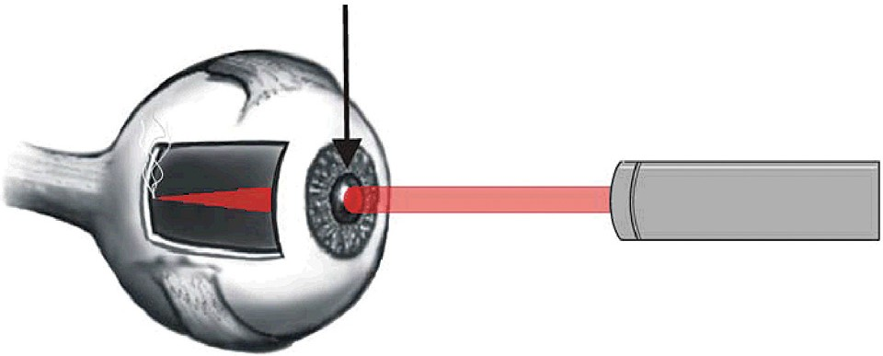

An incident laser beam striking directly in line with the lens is extremely dangerous. The beam is magnified over 100,000 times by the lens of the eye. The more divergence of the beam the less light strikes the eye. The more the mean is focused or collimated the greater the fluence of the beam and potential for injury

### Safety Goggles

Not all Safety Goggles are the same. The protective eyewear that came with your laser is manufactured specifically for the wavelengths emitted by the laser. Do not use protective eyewear from other manufacturers as they may not provide the appropriate level of protection.

Technical Specifications for proper usage include:

Wavelength Specific: Blocks 808nm (and 810nm)

OD, Optical Density of 4-6

Meets current ANSI Safety Standards

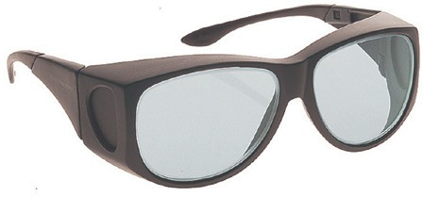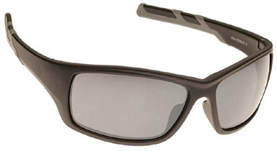

CAUTION!

**DO NOT remove protective eyewear until the operator returns the laser device to STANDBY mode. To do this, the operator must release the foot switch, touch the READY screen button on the display panel, and visually observes the laser device returning to STANDBY.**

### Using Safety Goggles Correctly

Laser Safety Goggles are vital for eye protection in the presence of laser radiation. Since accidental laser radiation exposure can cause irreversible damage to the human eye, protective measures must not be taken lightly.

1. Ensure that the eyewear has appropriate optical density for the intended use, 4-6 OD.
2. Ensure that the wavelength protected is the same as the laser energy emitted from the laser.
3. Remove all reflective objects (such as rings, metal watchbands, and jewelry) prior to treatment with the laser. Indirect or direct eye contact with the laser beam or with scattered laser light from any reflective surfaces will cause serious damage, irreparable corneal and/or retinal damage, and possible blindness to one or both eyes.
4. Do not allow any reflective object to fall into or obstruct the path of the laser beam.
5. Always wear protective eyewear. Any person present during the laser operation must wear protective eyewear.
6. Never look directly into the end of any therapy output coupler on the handpiece.
7. Never direct the laser light directly in the area of the eyes, or direct the laser beam at anything other than the skin area to be treated.
8. Do not remove the Client’s Safety Goggles until the Certified Laser Technician has turned off the laser, put it in STANDBY, and notified the Client that it is safe to remove them.

### Laser Safety Warning Signs

Lasers require the use of specific Warning signs for the safe operations of each laser system.

Warning signs must be in view outside and inside the room where the laser treatment is being performed. Warning signs must meet current ANSI recommendations.

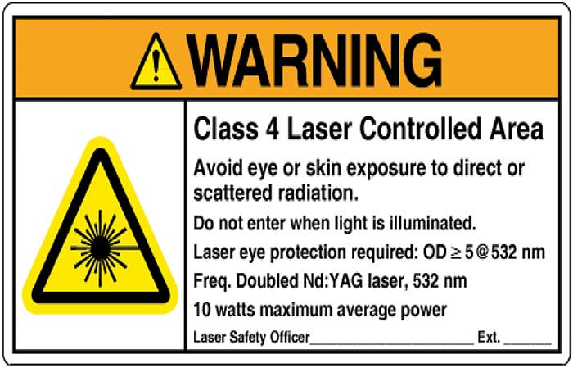

Example of a Class IV WARNING sign. This example is used with 532nm wavelength lasers with 10 watts of output. VADER Safety Signs have 600 watts, 808nm, OD 4-6

CAUTION!

**Place LASER WARNING SIGN at location entrance where people will use the APT Artisan VADER.**

### Environmental and Electrical

The laser device is air-cooled and designed for use in a well-ventilated office environment that maintains relative humidity and temperature conditions conducive to conventional human comfort. Minimum operating temperature is 60 degrees Fahrenheit. Maximum operating temperature is 90 degrees Fahrenheit. Optimal is 70-80 degrees Fahrenheit.

### Federal Regulation Compliance

Aesthetic ProTools’s user information is in compliance with section 1040.10 of Title 21 of the code of Federal Regulations, Chapter1, Subchapter J of Health and Human Services, Food and Drug Administration, and Center for the Devices and Radiological Health.

### Laser Safety Supervision

Designate at least one person at each facility that utilizes this device as LSO, Laser Safety Officer, responsible for providing training and record keeping on all operating safety procedures. ANSI Z136.1 defines the job responsibilities of a Laser Safety Officer

### Warnings

Please read and adhere to the following warnings:

* Improper use of system controls or performance of procedures other than those specified in this User’s Manual may result in hazardous radiation exposure.
* Failure to comply with all safety instructions and warnings may expose all participants to harmful levels of laser radiation and/or dangerous levels of electrical currents.
* NEVER direct the laser beam at anything other than the area to be treated.
* NEVER allow the eyes of any person to look directly into the distal end of the output coupler connected to an active laser device, WITH or WITHOUT wearing appropriated laser-emission protective eyewear.
* DO NOT ALLOW any reflective object to fall into or obstruct the path of the laser energy produced by this device. Scattered or reflected laser energy can cause serious damage to eyes and skin. The operator, all assistants, and patient must remove all reflective objects (such as rings, metal watchbands, and jewelry) prior to treatment with this device.
* There are no user-serviceable components inside this laser device. Therefore, do not attempt to gain access to any internal device component. Doing so may cause serious and/or irreversible injury.
* DO NOT remove protective eyewear until the operator returns the laser device to **STANDBY** mode. To do this, the operator releases the foot switch, touches the **READY** screen button on the display panel, and visually observes the laser device returning to **STANDBY**.
* The use of flammable anesthetics or oxidizing gases such as nitrous oxide (N2O) and oxygen should be avoided. High temperatures produced in normal use of the laser equipment may ignite some materials, for example cotton or wool, when saturated with oxygen. The solvents of adhesives and flammable solution used for cleaning and disinfecting should be allowed to evaporate before the laser equipment is used. Attention should be drawn to the danger of ignition of endogenous gases.

### Precautions

Please read and adhere to the following precautions:

* NEVER let untrained personnel operate this device unless directly supervised by a CLT or SLT trained and experienced with this device.
* This laser device produces 808-nanometer near-infrared laser energy that can be an extreme hazard to the eyes of any living being. Irreparable corneal and/or retinal damage may occur if a person exposes one or both eyes to direct and indirect (reflected) laser energy.
* The Protective eyewear supplied with this device has an optical density rating > 4.0 for 808 nm laser emission. All personnel present during device operation must wear this eyewear. Contact Aesthetic ProTools at

1-480-361-8585 to purchase additional sets of protective eyewear for this device.

* DO NOT remove protective eyewear until the operator returns the laser device to **STANDBY** mode. To do this, the operator releases the foot switch, touches the **READY** screen button on the display panel, and visually observes the laser device returning to **STANDBY**.
* Select a secure, properly equipped, and well-ventilated location in which to install and operate the laser.
* Place **LASER WARNING** signs at treatment room entrances where people may use the APT VADER 808. Please contact Aesthetic ProTools at 1-480-361-8585 for more information regarding these signs.
* Always put laser in **STANDBY** mode or switch the device off prior to adjusting or preparing the output optical coupler.
* Never leave this device in the Emission-enabled (READY) mode unattended.
* Remove the key from device’s key switch when not in use to prevent unauthorized and/or unqualified use of the device.
* Turn the device off before relocating equipment within the room or in another room.
* Never press the foot pedal/switch without first verifying the safe orientation and proper positioning of the hand piece, the distal (output) end of the optical coupler and ensuring compliance to all safety precautions.
* During any laser procedure, do not allow any nonessential personnel into the treatment area.
* Never allow untrained personnel to operate this device unless directly supervised by a CLT or SLT that is experienced with this device.
* If the laser fails to operate properly, immediately contact Aesthetic ProTools at 1-480-291-5880.

### Labels and Symbols

The following labels appear on the Aesthetic ProTools laser systems.

**MANUFACTURER’S GENERAL IDENTIFICATION LABEL –** Located on the back of the device. The label displays the manufacturer, model number, serial number, date of manufacture of the Aesthetic ProTools laser system. This label also presents various regulatory compliance declarations.

This label is affixed to the rear of the laser device’s cabinet.

Maximum amperage draw is 15A, preferred input electric to be used is a 20A isolated circuit.

|  |
| --- |
| **Aesthetic ProTools, Inc.** |
| Name  **Artisan** **VADER** |
| Model v.2 |
| SN APTxx-xxx  Rated voltage 110VAC  Input wattage 1500W  Max.Amp. 15A  Mode Pulsed Output  Mfg.date xx/xx/xxxx  Manufactured for USA  1(480)291-5880  [www.aestheticprotools.com](http://www.aestheticprotools.com)  Diode Laser 808nm =/- 600 W (max) |

**GENERAL SAFETY DECLARATION LABEL –** Located on the side of the device, this label indicates the laser classification. It warns of the radiation exposure hazard potential to eyes and skin.



**LASER EMISSION (APERTURE) LABEL –** Located on the handpiece of the device, the laser emission label indicates that the laser energy emission occurs from the diode at the optical coupler attachment location.

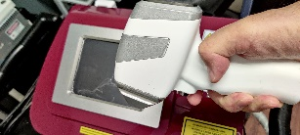

Laser aperture

NOTE

**The laser WILL NOT enable unless an optical coupler is installed in the emission port.**

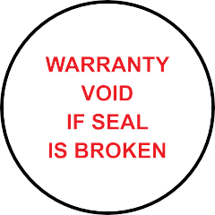

**Warranty Seal Label –** These labels are positioned on the underside of the laser device in such a way that any attempt to open the panels of this device will break this seal. If a machine is returned for service and the seal is broken, the Warranty will not be considered valid.

##### Other Safety Signs

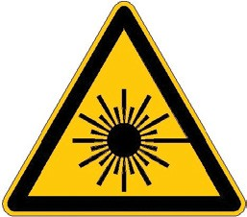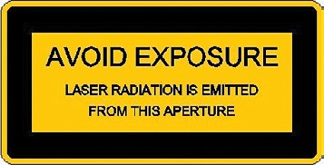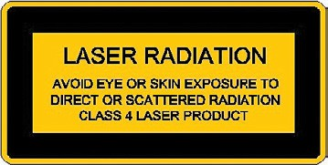

Laser Danger Laser Output Window External Interlock Connector On

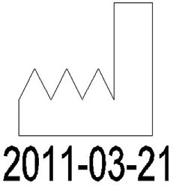

Refer to Operating Manual Production Date



Manufacturer Safety Mark

### Safety Features on Device

The following component devices have specific safety-related features. All individuals who use this laser device should be familiar with the purpose and the operation of these components.

**EMERGENCY POWER OFF SWITCH –** This switch is located on the front panel of the APT Artisan VADER. Pushing the switch in terminates all electrical power to the laser device’s microprocessor and laser-emitting components. Resetting the switch restores power. To reset the **EMERGENCY POWER OFF SWITCH**, the user must press, twist, and rotate in the direction indicated by the arrows, then release it as the switch pops out, returning it to its normal position.

**KEY ACTIVATED POWER SWITCH –** This switch is located on the front panel of the APT VADER.

A key is required to activate the APT VADER. The user inserts the supplied key into the key switch and turns it 90 degrees clockwise. When the key switch is in this position, it cannot be removed.

After powering OFF the device using the key switch (a 90-degree, counter-clockwise turn), the user should remove the key and store it properly to prevent unauthorized or unexpected laser system operation.

**SAFETY INTERLOCK –** This device is equipped with a safety interlock located at the rear of the device. If the interlock is not inserted into the DB9 connector, all electrical power to the controls and laser components is terminated. The safety interlock MUST be inserted before the device can power on.

**POWER ON/OFF VISUAL INDICATOR –** Located on the front of the laser device, the LCD panel is illuminated continuously whenever the user activates the key switch and the emergency power off switch is disabled.

**LASER-EMISSION INDICATOR** The laser device emits an optional continuous alert tone whenever the treatment laser emits energy. The device also emits an optional beeping tone during the laser emission enabling notification sequence. The laser is also equipped with a visual indicator. The LCD touchscreen panel will display and blink “EMISSION” during the emission mode.

NOTE

**The operator can intentionally disable the alert tone using the setup display screen. To enable the alert tone when it has been disabled, select the appropriate alert tone operating parameter on the setup display (refer to the Operation Section).**

**INTERNAL LASER ENERGY MONITOR –** This is an internal device that monitors the intensity of laser energy generated whenever laser emission occurs. This monitor aborts laser emission if the laser device is unable to maintain the laser energy output set by the user.

**MANUAL RESET –** To reset the system the user is required to manually power off then on the system or press the **RESET** button on the touchscreen when the LASER EMISSION ABORTED message is displayed.

### Laser Safety Checklist

Check List for the Laser Technician and Laser Safety Officer (LSO)

✔ Appropriate warning signs posted

✔ Access to laser and treatment area is secure and controlled

✔ Visually inspect and clean all optical surfaces for grease, oil, dirt, debris, etc.

✔ Test laser for proper function

✔ Visually inspect and, if required, clean all safety goggles using the APT glasses cleaning protocol

✔ Goggles available for all persons in Nominal Hazard Zone (NHZ)

✔ Extra goggles placed outside treatment room for visitors

✔ Sources of potential laser beam reflection and scatter controlled

✔ Treatment protocol established for the procedure and communicated to the Client

✔ Laser injury management protocol in place for accidental injury

✔ Document laser treatment and post-treatment outcomes

### Sources for Additional Information and Assistance on Laser Safety

##### Center for Devices and Radiological Health

Office of Compliance 2098 Gaither Rd.

Rockville, MD 20850

Tel: 301-594-4654

Fax: 301-594-4672

<http://www.fda.gov/cdrh/index.html>

IMAj Institute

8939 East Talking Stick Way

Suite B-2

Scottsdale, AZ 85250

[www.imajinstitute.com](http://www.imajinstitute.com)

Tel: 480 361 8585

##### Laser Institute of America

12424 Research Parkway, Suite 125

Orlando, FL 32826

Tel: 407 380 1553

Fax: 407 380 5588

<http://www.laserinstitute.org/>

# CLINICAL INDICATIONS

The unit can realize vaporization of hair, photocoagulation of small veins, collagen synthesis, hypertrophic scar breakdown, and other related results.

The Laser Technician should be aware of the clinical applications suitable for the laser equipment when the exact therapeutic intentions of the laser protocol in each clinical case cannot be known clearly.

Treatment is prohibited in patients who have: heart trouble, psychosis, hypertensive diseases or any patient who has been proved to be unsuitable for laser therapy.

**6a. Laser Hair Reduction Protocol**

**HAIR REDUCTION PROTOCOL**

**(Artisan VADER)**

***This protocol is applied to the following procedures:***

Face/Neck, Chest, Arms, Underarms, Abdomen, Back, Brazilian, Buttocks, Legs, Feet, Toes, Hands and Fingers

***Key. Sign & Glasses***

1. Obtain the key.
2. Place the warning sign on the door.
3. Place a pair of safety glasses on the outside of the door.
4. Have a pair of safety glasses for everyone in the treatment room, including client.

***Paperwork:***

1. Have the client sit on the treatment table, and make sure they are comfortable (Provide drape if needed.)
2. Review informed consent with client and ask medical questions.
   1. Photosensitive medications (avoid any CYCLINES for 2 weeks and ACCUTANE for 6 months) or recent medication changes? Antibiotics? Recent injectables within 4 weeks in treatment area? Metal implants? Medical devices? Accutane? Tanning within the last 2 weeks, sunburns in treatment area or irregular sun exposure? Permanent makeup in treatment area? (Always needs to be avoided with laser, if recently done need to avoid treatment for at least 1 month), Recent treatments on area? (most laser treatments in same area need to avoid further treatment for 1 month unless collagen (2 weeks) or Artisan (1 week) Self neutralizing peels (1 month) neutralized peels (2 weeks). Pregnancy? History of seizures related to energy or pulsed light. Any medical devices?
3. Check to make sure the client has signed & dated the consent form.
4. Sign and date consent form.
5. Review that medical history forms are completed and signed.
6. Review medical history form with client, checking for any new medications, pregnancy refer to medical questions. Update medical history form as necessary.
7. Review the settings used during the last treatment in the same area and make all notations treatment notes.
8. Conduct consultation about reason for treatment, client concerns, reaction to last treatment if applicable, address client goals for treatment, and give reasonable expectations for current session.
9. Take before photo (with signed consent) of hair grown out to track effectiveness and have a record of reduction.

***Preparation***

Skin prep is the most important part of giving an effective treatment. If prep is not completed properly the energy will not penetrate the skin, reducing the treatments effectiveness and could lead to possible burning.

1. Wash hands with antimicrobial soap.
2. Apply gloves. (If using latex, make sure the client has no latex allergies.)
3. Apply Skin Prep Solution to wet gauze complete first cleanse, shave if needed.
4. Cleanse the area twice thoroughly with gauze first then Silicone scrubber.
5. Rinse the area twice thoroughly with water removing all attenuators.
6. Provide proper safety glasses for everyone in the room.
7. Disinfect the handpiece with alcohol sprayer and lens cloth.

**Procedure:**

1. Adjust settings according to client tolerance.

* Set the appropriate Fitzpatrick of client.
* Set the power starting at 3 Joules for the first-time client (look at tissue reaction and refer to notes from prior appointments) should see erythema, perifollicular edema, post treatment stubble or client should feel minor heat prickling sensation at a tolerable level.
* Milliseconds (ms) will adjust to the Fitzpatrick automatically, however, 50-70 ms is normal. ms will need to be adjusted as you raise your joules and hertz.
* Pulses per second (frequency measured in hertz) range from 3-10 hz, look at tissue response, check in with client about sensation. Hertz is determined based on size of treatment area and hand speed. The larger the treated area the faster the shooting speed can be.
* Make sure 12x12 lens or 12mm x 20mm optic is installed, avoid 4mm x 4mm optic for LHR.

1. Check to see that shots have been reset from previous treatments.
2. Apply a layer of Ultrasound Gel with a *spatula* to the area being treated.
3. Check the settings prior to the treatment.
4. Press the Ready mode button.
5. Always keep the hand piece perpendicular while maintaining full contact.
6. Press on the foot pedal or hand trigger to pulse, holding down until the series of shots are complete.
7. Moving in a quick, sweeping movement to disperse shots. Check tissue response and check in with client about sensation. If you see an appropriate reaction and the treatment feels comfortable, but effective, for client, continue the procedure. If the setting is not enough power to cause perifollicular edema, gradually raise joules 2-5j at a time, adjust hand speed and hertz to make sure you’re getting adequate heat buildup and coverage. If the chosen setting is too much power, lower joules and hertz, and move the handpiece faster while pulsing.
8. Complete two passes (N, S, E, W) allowing time for TRT. Or crosshatch to ensure adequate coverage. Map out treatment area with gel, if a larger body part, and separate into smaller sections. Cover treatment area with 0-50% overlap with the N, S, E, W or cross hatching techniques based on tissue response.
9. Press the Stand-by mode.
10. Remove gel from the treated area with spatula, clean off skin with towel and apply SPF or Arnicare if inflammation is present.
11. Record settings on treatment notes.
12. Turn off the machine.
13. Remove key from machine.
14. Clean the laser optic with alcohol spray and lens cloth. Remove magnetized lens to clean gel behind magnet, use lens cloth and alcohol. Wipe off the base of machine and workstation with Barbicide wipes.

**6b. Collagen Synthesis Protocol**

**COLLAGEN SYNTHESIS PROTOCOL**

**This protocol Is applied to the following procedures: Hair Reduction, Skin Rejuvenation, Skin Tightening, Wrinkle Reduction, Facial Erythema Reduction, Solar Lentigo Reduction, Acne Scar Reduction and Collagen Synthesis treatments in the following areas: Face/Neck, Chest, Arms, and Hands**

**(APT VADER)**

***Key. Sign & Glasses***

1. Obtain the key.
2. Place the warning sign on the door.
3. Place a pair of safety glasses on the outside of the door.
4. Have a pair of safety glasses for everyone in treatment room including client.

***Paperwork:***

1. Have the client sit in the chair and make sure they are comfortable (Provide drape if needed.)
2. Review informed consent with client and ask medical questions.
   1. Photosensitive medications (avoid any CYCLINES for 2 weeks and ACCUTANE for 6 months) or recent medication changes? Antibiotics? Recent injectables within 4 weeks in treatment area? Metal implants? Medical devices? Accutane? Tanning within the last 2 weeks, sunburns in treatment area or irregular sun exposure? Permanent makeup in treatment area? (Always needs to be avoided with laser, if recently done need to avoid treatment for at least 1 month), Recent treatments on area? (most laser treatments in same area need to avoid further treatment for 1 month unless collagen (2 weeks) or Artisan (1 week) Self neutralizing peels (1 month) neutralized peels (2 weeks). Pregnancy? History of seizures related to energy or pulsed light. Any medical devices?
3. Check to make sure the client has signed & dated the consent form.
4. Sign and date consent form.
5. Review that medical history forms are completed and signed.
6. Review medical history form with client, checking for any new medications, pregnancy refer to medical questions. Update medical history form, as necessary.
7. Review the settings used during the last treatment in the same area and make all notations treatment notes.
8. Conduct consultation about reason for treatment, client concerns, reaction to last treatment if applicable, address client goals for treatment, and give reasonable expectations for current session.
9. Take before photo (with signed consent) of treatment area to track effectiveness and have a record of results.

***Preparation***

Skin prep is the most important part of giving an effective treatment. If prep is not completed properly the energy will not penetrate the skin, reducing the treatment’s effectiveness and could lead to possible burning.

1. Wash hands with antimicrobial soap.
2. Apply gloves. (If using latex, make sure the client has no latex allergies.)
3. Apply Skin Prep Solution to wet gauze complete first cleanse, shave if needed.
4. Cleanse the area twice thoroughly with gauze first then Silicone scrubber.
5. Rinse the area twice thoroughly with water removing all attenuators.
6. Provide proper safety glasses for everyone in the room.
7. Disinfect machine handpiece with alcohol sprayer and lens cloth.

**Procedure:**

1. Adjust settings according to client tolerance.

* Set the appropriate Fitzpatrick of the client to be treated.
* Set the power starting at 2 Joules for the first-time client through 12 Joules (look at tissue reaction and refer to notes from prior appointments)
* Tissue reaction should be mild erythema and edema. Client sensation should be minimal heat or prickling. Keep in mind pigmented areas, thinned skin or close to bone will be more reactive.
* Milliseconds (ms) will adjust to the Fitzpatrick automatically, however, 50-70 ms is normal. ms will need to be adjusted as you raise your joules and hertz.
* Pulses per second (frequency measured in hertz) range from 3-10 Hz, look at tissue response, check in with client about sensation. Hertz is determined based on size of treatment area and hand speed. The larger the treated area the faster the shooting speed can be.
* Verify that you have the 4mm x 4mm optic installed.

1. Check to see that shots have been reset from any previous treatments.
2. Apply a layer of Ultrasound Gel with spatulato the area being treated.
3. Check the settings prior to the treatment.
4. Press the Ready mode button.
5. Always keep the hand piece perpendicular while maintaining full contact.
6. Press on the foot pedal or trigger to pulse, holding down until the series of shots are complete.
7. Moving in a quick, sweeping movement to disperse shots. Check tissue response and check in with the client about sensation. If you see an appropriate reaction and feel comfortable to continue on the procedure. If your chosen setting is not enough power gradually raise the joules 2-5j at a time and adjust hand speed and hertz to make sure you are getting adequate heat build-up and coverage. If too much power lower joules and hertz and move the handpiece faster while pulsing.
8. Complete two passes (N, S, E, W) allowing time for TRT. Or crosshatch to ensure adequate coverage. Map out the treatment area with gel if a larger body part and separate it into smaller sections. Cover treatment area with 0-50% overlap with the N, S, E, W, or cross-hatching techniques based on tissue response.
9. Press the Stand-by mode.
10. Remove the gel from the treated area with a spatula, clean off the skin with a towel, and apply SPF or Arnicare if inflammation.
11. Record settings on treatment notes.
12. Turn off the machine.
13. Remove the key from the machine.
14. Clean the laser lens with alcohol spray and lens cloth. Remove the magnetized lens to clean the gel behind the magnet use lens cloth and alcohol. Wipe off the base of the machine and workstation with Barbicide.

# PRODUCT DESCRIPTION

### SPECIFICATIONS

Temperature is 5°-40°C (41°-104°F), relative humidity is less than 80%, and atmospheric pressure is 860hPa-1060hPa.

|  |  |
| --- | --- |
| **Laser Type** | Vertical Array Diode Energy Radiator |
| **Model** | Artisan VADER |
| **Wavelength** | 808nm±10nm |
| **Output Power** | 1-600W |
| **Operation Mode** | Single Pulse, Repeat Pulse |
| **Pulse Width** | 10ms-400ms |
| **Pulse Repetition Rate** | 1 Hz -10 Hz |
| **Transmission System** | Direct optical coupling to VADER |
| **Aiming Beam** | N/A - contact transmission |
| **Operation Interface** | Color Touch Screen |
| **Power Supply** | 110/220VAC, 15A, 50/60Hz |
| **Laser Class** | 4 |
| **Safety Classification** | Class IV – Type B |
| **Cooling** | Air/deionized water/TEC semiconductor/sapphire optical tip |
| **FUSE** | internal |
| **Dimensions** | 406 (W) x 534 (L) x 280 (H) mm/16” W x 21” L x 11”H |
| **Weight** | 331 oz./ 9.4 Kg / 20.7 lb. with coolant |
| **Waterproof Level** | IPX1 – protect from exposure |
| **Hand Piece Waterproof Level** | IPX1 – protect from exposure |
| **Safety Compliance** | CE 0197 |

### General Overview

The Artisan VADER consists of six main components.

1. Laser System
2. Integrated Color Touch Screen
3. The Hand Piece assembly
4. Optical coupler 12mm x 12 mm or 12mm x 20mm
5. Optical coupler 4mm x 4 mm
6. Power System cord

The Laser System consists of the VADER 808 diode laser system, power supply, control panel, safety shutter and the embedded computerized control system.

### Front

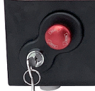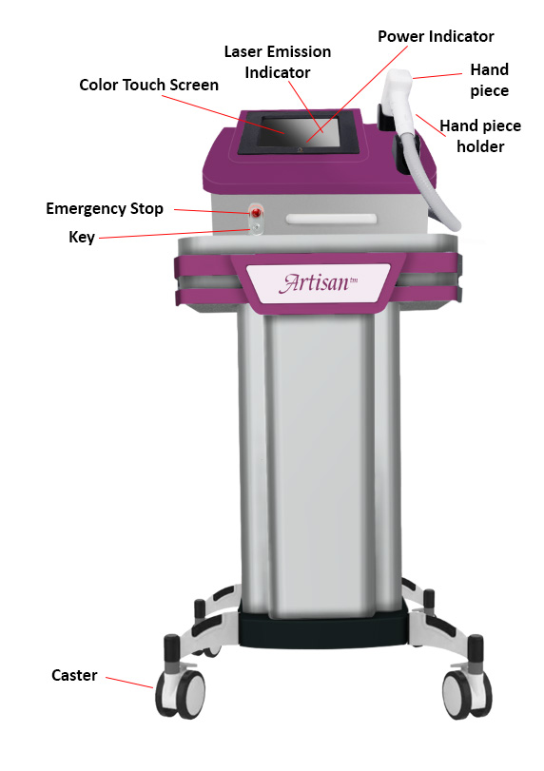

On the front of the APT VADER 808 you will find:

1. Caster
2. Emergency Stop
3. Laser Emission Indicator (YELLOW on touch screen)
4. Power Indicator (GREEN on touch screen)
5. Color Touch Screen
6. Hand Piece
7. Hand Piece Holder
8. Key

### Casters

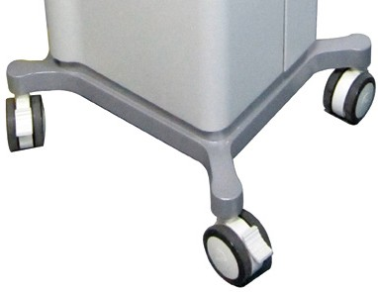

There are four **CASTERS.** Each can rotate 360 degrees. The device can be easily moved by pushing in any direction.

### Emergency Stop

The **EMERGENCY STOP** connects to the system’s power supply. In the event of an emergency, pressing the Emergency Stop will immediately cease laser emission. Before restarting, turn the emergency stop button clockwise, as the arrows indicate, so the knob brings up the emergency stop button.

### Alarm Indicator

The Artisan VADER offers an **ALARM INDICATOR** for system errors. The Alarm Indicator will be red when safety system alarms. For example, if the indicator is on and the system alarms, the screen will show needed information. The foot switch cannot control the output of the laser while the ALARM INDICATOR is active. Reset the VADER after satisfying the problem indicated by turning the key off, waiting 30 seconds and turning it back on.

### Laser Emission Indicator

The **LASER EMISSION INDICATOR** will be yellow when the laser is emitting. The action of the indicator synchronizes with the laser.

The Laser Emission Indicator may be on if the system is in an emergency or a non-normal state. At that time, the system will stop all the output and the touch screen will show error information, and the system will signal with an alarm.

ATTENTION!

**Press the EMERGENCY STOP to terminate laser emission if the emission indicator light is on constantly.**

### Power Indicator

The **POWER INDICATOR** will be green if the power supply of the laser is operating normally.

### Color Touch Screen

The high-resolution **LCD** **COLOR TOUCH SCREEN** is very sensitive. Use fingers or a pointing device to touch the icons to adjust the programs. Do not impact the console screen or the hand piece screen. The screens may break under stress. Be aware, this is not a warranty repair as the device was delivered unbroken.

ATTENTION!

**Do not put heavy objects or apply excessive pressure to the touch screen to prevent display distortion. Avoid touching the screen with sharp objects to prevent scratching the surface.**

**Caution must be taken to prevent liquids from contacting the surface of the touch screen.**

### Encode Icons

The **ENCODE** icons are used for adjusting the parameter value. **Energy** (joules), **Pulse width** (pulse duration), and **frequency** (hertz) are adjustable using the icons. You can also select the Fitzpatrick of your client for software assistance. **Current shot** refers to laser impulses during the time the VADER has been turned on this time. **Total Shot** refers to an accumulative shot count on all cases performed on this diode.

### Hand Piece

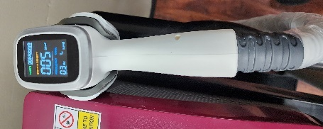 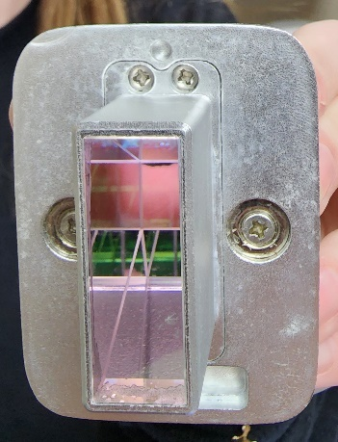**

The **VADER HAND PIECE** is **V**ertical **A**rray **D**iode **E**nergy **R**adiator hand piece which is matched with specially designed optics channeling all produced energy directly to the output side of the chosen optic. There are no linking optics that might degrade the energy as it is transferred to the treatment site. Depicted is the 12 mm x 12 mm square optic often used for laser hair reduction. A 12mm x 20mm optic is also available for laser hair reduction use. A 4mm x 4mm optic is used for collagen synthesis, vascular and pigment treatments. More optics may be added as research of optimized uses continues.

The Hand Piece can be placed in the Hand Piece Holder on the right side of the VADER 808 when not in use.

### Hand Piece Holder

The **HAND PIECE HOLDER** protects the Hand Piece from contamination when not in use.

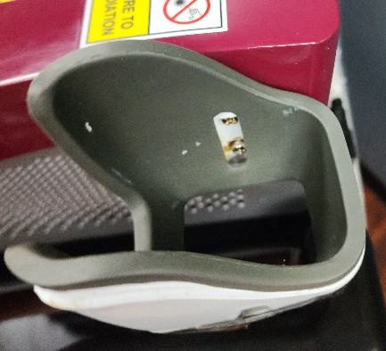

Notice the foam liner within the hard plastic outer shell. The hand piece inserts from the front with the cord hanging on the front right of the APT VADER.

### Rear Panel

1. Refill Drain
2. 110VAC cord connection
3. Hand piece mount
4. Coolant water vent
5. Radiator air vent
6. Foot Switch connector (optional)

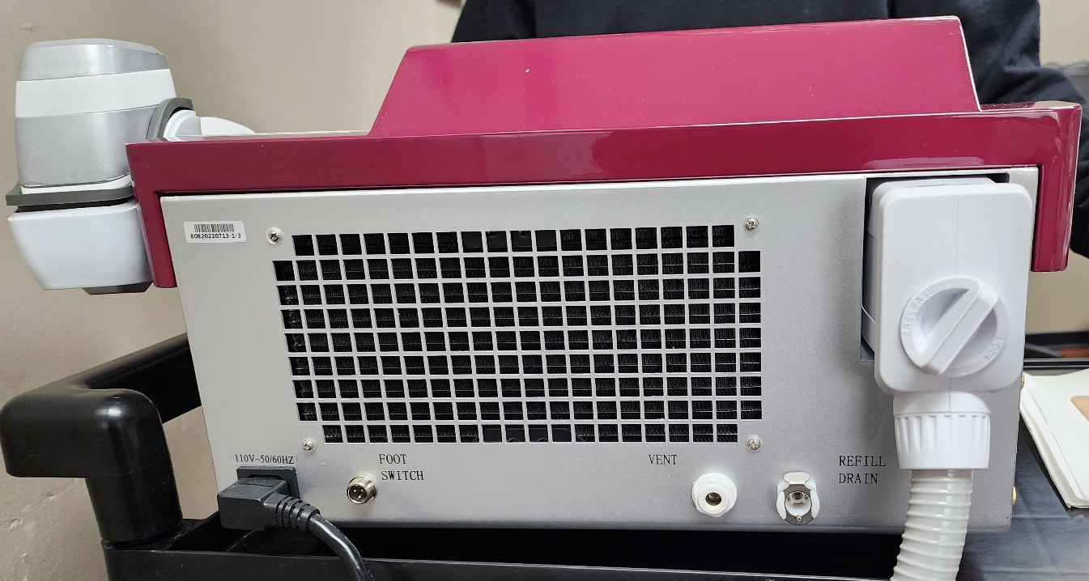

ATTENTION!

**Take care while inserting and removing the Foot Switch and the Power Cord.**

# OPERATING THE LASER DEVICE

### Introduction

To guarantee a faultless operation of the APT VADER during a treatment the following requirements must be met:

* The device has already been correctly plugged into an 110VAC electricity source.
* Safety goggles are available for all the people in the room.
* The hand piece and delivery optic have been fixed to the APT VADER laser aperture (Connect the Hand Piece and/or optic if necessary).
* The APT VADER has been energized using the correct key and the software screen is illuminated, and the software operation is evident.
* The footswitch has already been connected, if you choose to use it instead of the hand piece button.
* The emergency stop has been popped out and is not depressed.

### Starting the Laser Device

To start the laser unit, turn the main switch ON and the key clockwise to the ON position. The power indicator will turn green and the system fans will be working. At the same time, the LCD screen lights up.

Initially, the Landing Screen code is 123456.

The system will perform a Diagnostic Self Check. If there are problems during startup, the system will display them. The system takes 90 seconds or less to start up. For more information, please see Section 9 – TROUBLESHOOTING.

### Main Menu Screen

1. **Power** Icon
2. **Screen Lock**
3. **Settings** Icon
4. Optic spot size
5. Icon for Spot selection
6. **A picture containing text, indoor, electronics

   Description automatically generatedEnergy** expressed in Joules per centimeter squared.
7. Energy Increase or Decrease
8. **Pulse width** expressed in milliseconds.
9. Pulse width Increase or Decrease
10. **Frequency** expressed in Hertz or shots per second
11. Frequency Increase or Decrease
12. Coolant **Temperature** expressed in Centigrade.
13. **Skin Type**, Fitzpatrick of the Client’s skin, scroll and select
14. **Current Shot**, how many shots in this current treatment
15. **Total Shot**, the cumulative shots on this diode
16. Reset Shot Count or Reset Cumulative Shot Count



1. **Standby** – put the laser in a non-shooting mode for safety
2. **Ready** – put the laser in a shooting mode for treatments

### Setting Laser Operations

### Set Laser Output Power

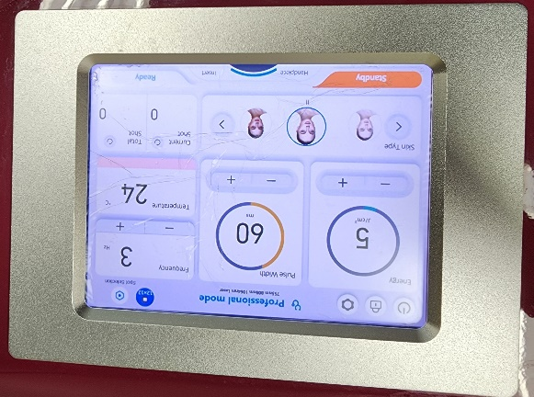

There are three ways to change or adjust the power level:

1. Pressing the **Energy** - + icon will decrease or increase the energy.
2. Pressing the **Pulse width**- + icon will decrease or increase the pulse duration, time of the individual pulse.
3. Pressing the **Frequency** - + icon will decrease or increase the number of laser impulses released per second.

### Select Laser Emission Mode

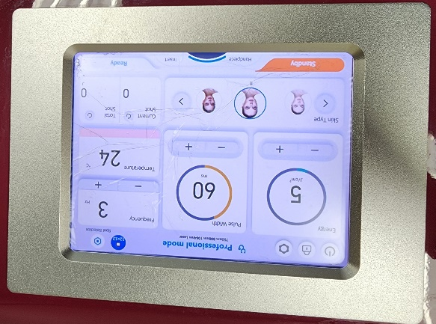

There are 2 **LASER EMISSION MODES.** When selected, the corresponding button is brightly colored:

1. **Standby –** In this mode, the laser will not fire.

##### Ready – In this mode, the laser is Ready to fire if the hand piece button or the foot pedal is depressed. The laser will continue to fire as long as either activation method is depressed. It will fire at the rate per second indicated on the Frequency indicator, expressed in Hertz.

### Set Laser Pulse Width

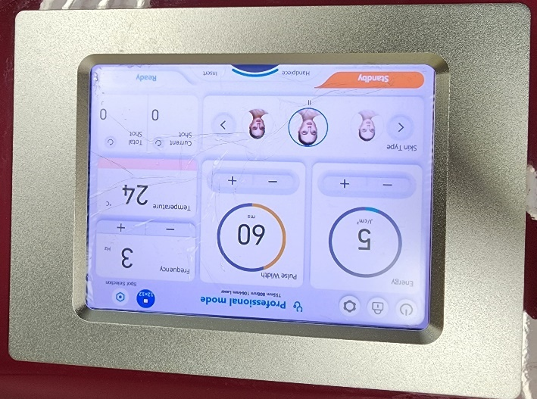

The **Pulse Width** is the laser emission pulse duration. The Pulse width ranges from 5ms-400ms. Pressing + or – adjusts the value.

### Set Laser Energy

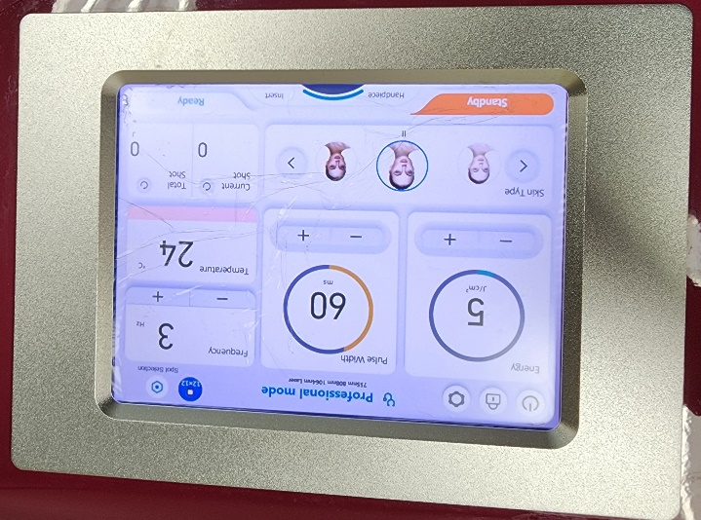

The **Energy** is the laser emission power density setting provided during one pulse period expressed in Joules per centimeter squared. The available **Energy** ranges from 2 J/cm2 to 166 J/cm2. Pressing + or – adjusts the value.

Available wattage is 600 watts from the APT VADER diode. Output is software limited to protect the Client.

### Reset the Current Shot

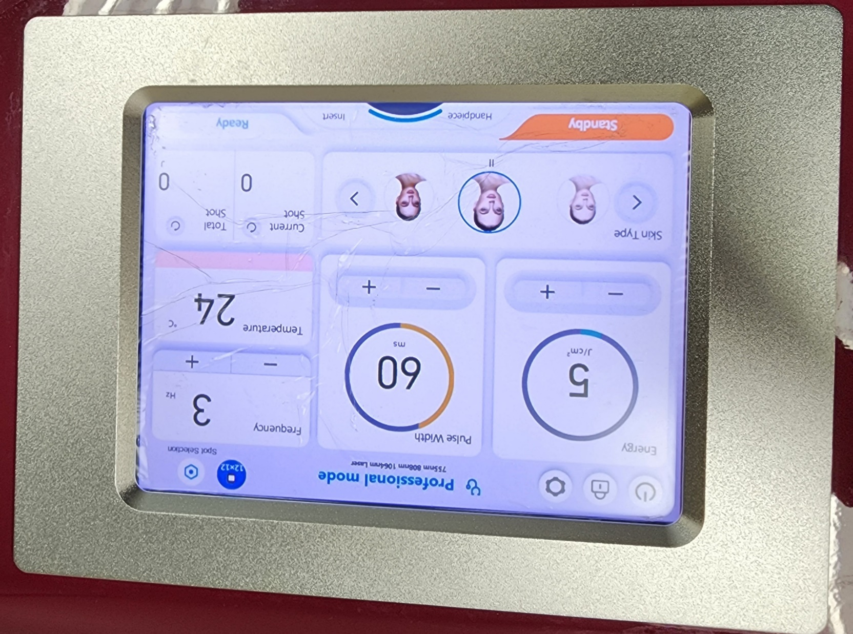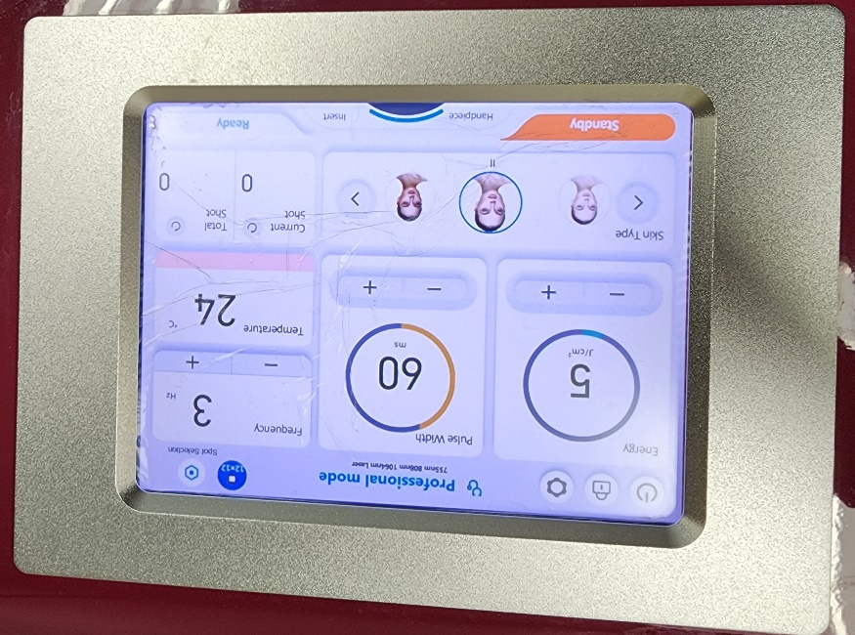

As APT VADER is used in a procedure, the number of shots displayed under “Current Shot” will increase to reflect the total number of shots being administered, until the laser operation is paused or stopped. It is helpful to press the reset arrow before each procedure to return the starting point to “0” so only the shots used in the current treatment are shown. The software should return to “0” each time it is turned off, but if not, press reset to cause a display of “0” shots to get an accurate count.

### Standby and Ready

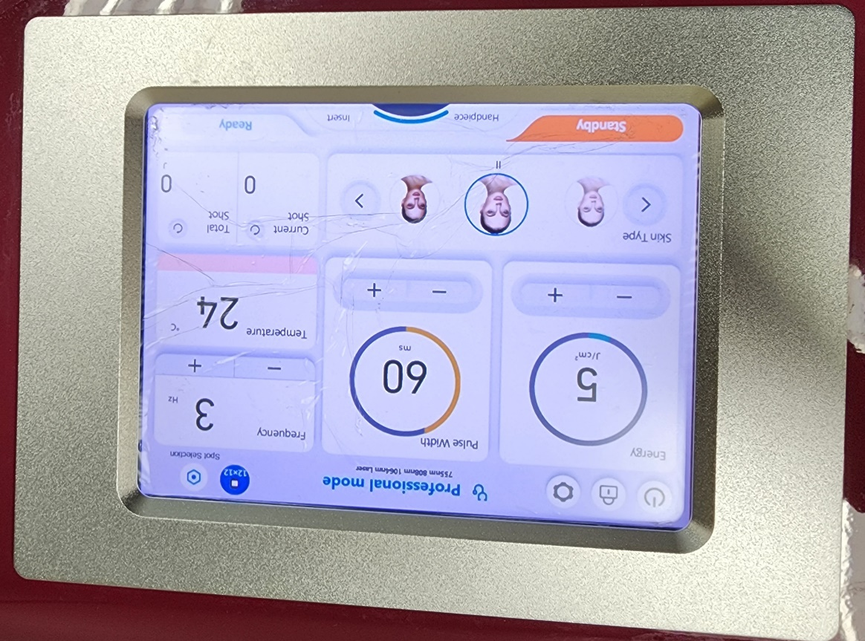Pressing the **READY** or **STANDBY** buttons, changes from one status to another.

**STANDBY:** In this mode, the laser power supply is disabled.

**READY:** In this mode, the laser power supply is enabled. Pressing the Foot Switch or pressing the Hand Piece button sends out the laser.

Pressing the On / Off Switch on the Hand Piece or Foot Switch, when in ready mode, this will activate the Laser beam (808 nanometers/infrared)

### Menu Interface

### Settings mode

In main interface press **SETTINGS (small gear on upper left of the control screen)** to access the following user settings:

1. **Volume or SPEAKER SOUND –** You can adjust the Sound of the Intermittent Beeping from ZERO Sound to a High Sound
2. **Level cooling –** You can adjust the temperature of the energy delivery optic that touches the skin. There are four settings plus off. Generally, you want the maximum cooling unless the cold is uncomfortable for your client. If so, touch the frost symbols until fewer are showing. Three frost symbols are 25% cooler than four frost symbols. Two frost symbols are 50% warmer than four frost symbols.
3. **Mode select –** You can enable and disable the Hand piece and/or foot pedal with this icon. Press the Save to accept the changes you have made or Cancel to discard your changes. You will then return to the Main Operational Screen.
4. **System Information-** This is the information on the screen left block –
   1. The equipment serial number is the top line.
   2. The hand piece serial number is the second line.
   3. Hardware refers to build identification. Each build batch has a different number than the device.
   4. Software ID is next indicating what software version is currently operating in the device. This ID code will change with software updates.
   5. Water Quality is a code for the condition of the coolant water. Repair people use this information in determining the cause of a fault.
   6. Hand piece version is a numeric description of the attached hand piece.
   7. Total Shot is the cumulative shot count on this device since the diode was installed.

# TROUBLESHOOTING

|  |  |  |
| --- | --- | --- |
| **PROBLEM** | **POSSIBLE CAUSE** | **SOLUTION** |
| Main switch is turned on but the unit does not start and the power indicator is off | 1. EMERGENCY STOP button is pressed. 2. The fuse is burned out. 3. No incoming power from the plug | 1. Turn the EMERGENCY STOP button to the normal position 2. Unplug the power line and call Service. 3. Try a different plug |
| Error Code information on the screen | 1. Water flow is inadequate. 2. Foot Switch does not operate. 3. System displays error code | 1. A. Add coolant water.   B. Call Service and report the Error code.   1. Connect the Foot Switch 2. Write down the code and contact Aesthetic ProTools. |
| Temperature too high | Temperature more than 35°C | Turn off the laser until the temperature sensor is about 30 |
| Temperature too low | Temperature less than 10°C | Raise the room temperature |
| Power Supply error | Laser current too high | Call Service |
| Foot Switch does not operate | Foot Switch is disconnected | 1. Re-connect Foot Switch 2. Settings, enable foot pedal mode |
| Hand Piece does not operate | Hand piece is disconnected | 1. Reconnect the hand piece. 2. Settings, Enable hand piece |
| No power when starting laser | 1. Power cord unplugged. 2. Emergency stop switch is depressed. | 1. Plug in power cord. 2. Turn clockwise to pop- up the emergency stop switch. 3. Turn Emergency button counterclockwise ¼ turn. It should pop out. 4. Verify key rotation. |
| Cannot start up, no display | 1. Verify incoming electrical source. | 1. Check the 110VAC plug in to be sure it is working. 2. Check 110 VAC cord connection on the back of VADER 3. Call Service |
|  |  |  |
|  |  |  |
|  |  |  |
|  |  |  |

# MAINTENANCE

### Optical Coupler Maintenance and Cleaning

1. The changeable optics used on the hand piece are very fragile. Only handle them over a flat surface covered in a soft cloth in case you drop it. Chipping the optic will destroy it.

Any dirt or material on the output optic face can burn or damage the optic.

1. Store the output optics in a soft, clean container that will close and protect them from dropping, having items sit or be dropped on them, protect them from inappropriate handling, protect them from dust and dirt.
2. Wear latex or nitrile gloves that are powder free when handling the optics. Wash your gloved hands with soap and water. Rinse well. Wash your gloves, on your hands with pure alcohol to remove any oils before handling these optics.
3. **Clean the surfaces of the optics using anhydrous alcohol or high-grade acetone. Use lint free optical lens tissues with the cleanser. Never touch the optic surfaces with dry lens paper, paper towels, gauze or your bare fingers.** **Do not blow on the optics to remove lint of dust.**

**Oils from your breath will contaminate the optic.**

NOTE:

**Never touch the optics with your bare skin. The oils on your skin may permanently damage the optic.**

### Main Unit Maintenance

The APT VADER is a precise Aesthetic device and should only be maintained by personnel authorized by the Company to ensure compliance with all Warranty Requirements.

1. When the Optics are removed, cover the Aperture with the Protective Hat. The optic should be cleaned with alcohol prior to replacement as described above.
2. If the optics are removed, cover the diode output cavity the optic came from to protect it from dust and dirt. Never put your finger in the diode cavity for any reason.
3. Do not touch the screen with hard or sharp objects or scrub the screen with a reagent. Clean with a soft material.
4. Avoid shaking or hitting the laser device during transportation.
5. **Changing the coolant water** 
   * Algae can be transferred from your bare hands to the cooling system causing significant damage. Alcohol wash your gloves, the funnel, and the outside of the hose connected to the funnel. Pour 2-3 ounces through the funnel to clean the inside of the hose.
   * The coolant water is continuously cleaned by the integrated filter located on the side of the cabinet. The built-in filter should be changed annually when the water is changed. The filter is attached with quick-connect fittings. Press on the lock to release each end of the filter at the same time and pull it free. Replace the old filter with an APT approved filter, and press in until it clicks. **Wear clean surgical gloves that have been washed using alcohol.** Remove the white vent cap (if in place). Use a funnel and hose assembly that has been alcohol wiped. Hold the funnel higher than the cabinet and add clean distilled (or better) water. Be sure to add 4 drops of approved APT algaecide to the coolant water. Add water until it runs out of the VENT port on the back of the VADER. Switch the VADER on in STAND-BY mode for 10 seconds. Turn the VADER off and add more water the same way as before. Stop adding water when it flows out of the VENT.

**TIP: When there is not enough water, the machine will alarm, you can hear a “Di, Di, Di ” sound. Then you need to add water (coolant). Need to check the water level every 2 weeks.**

# SERVICE

For any Service issue, contact your distributor or the company directly regarding any issues or concern, including:

1. Laser training
2. Regular maintenance and technical support
3. Accessories and equipment

##### Aesthetic ProTools, Inc.

8969 East Talking Stick Way

Suite C-5

Scottsdale, AZ USA 85250 Phone: 480-291-5880

Web: aestheticprotools.com

Email: [info@Aestheticprotools.com](mailto:info@aspenlasers.com)

# LASER THEORY AND LASER TERMS

### Laser Theory

All light is composed of photons. Photons are small packets of light energy – in the form of waves – with a defined wavelength and frequency. Photon energy is able to effectively penetrate the skin and underlying structures, therefore accelerating the healing process or creating changes in tissues. Light travels at a constant speed and oscillates up and down as it moves forward.

However, all light is not the same. It is measured in wavelengths, with each wavelength of light representing a different color, or section, of the light energy spectrum. The number of oscillations per second represents the frequency of each wavelength; shorter waves have a greater frequency than longer waves. Laser energy is coherent (well-ordered photons), monochromatic (single-color) light energy. When produced as a narrow, bright beam. Laser light holds its intensity until it is absorbed by a medium (substrate / the body). When applied to an organism, Laser light, tuned to specific wavelengths and frequencies, stimulates metabolic processes or thermal changes at the cellular level.

### Photo-Chemical Action

Lasers can have several controlled effects on different tissues, as photons of light can be preferentially absorbed by tissues based on the color (harmonic) of the tissue where the energy is applied. Exceeding the Thermal Relaxation Time (TRT) of tissue will denature the tissues and cause permanent change in the tissue. An example would be the vaporization of hair tissues resulting in the permanent removal of specific affected hair. While the absorption event is definable, adequate power density is also required to create the planned effect.

### Role of Chromophores

Chromophores are typically chemical components of various cells and sub-cellular organelles which absorb light preferentially based on the matching (similar) harmonics of the tissue compared to the light stimulus. An example of this is the higher absorption of black hair when any visible color of light energy is applied. Black, as we see it, is the absence of reflection of the light resulting in an “absence” of color which we refer to as black. When treating a black substance, eumelanin, every wavelength that is visible to humans is well absorbed by the eumelanin. Adequate power density application will lead to exceeding the TRT, denaturing the tissue and permanent change to the tissue through the thermal effect.

### Summary of the Photochemical Process:

Photons

## .

Absorbed by eumelanin in LHR & Pigment reduction or water in collagen synthesis.

## .

Targeted tissue absorbs the energy preferentially.

## .

Accumulated energy in the tissues exceed the TRT

## .

The tissue is denatured, changed, by the volume of energy absorbed

## .

The tissue emits water as steam

## .

Carbonized tissue remains.

### Laser Terms

**Accessible Exposure Limit (AEL)** is the maximum permissible power level for the appropriate class of laser as defined in ANSI Z136.1.

**American National Standards Institute, ANSI Z136.1 “Safe Use of Lasers”** – This standard establishes occupational exposure limits and laser safety practices in the United States.

**Aperture** is an opening through which laser radiation can pass.

**Aversion Response** is closing the eye and moving the head away to avoid exposure to laser light.

**Biological Amplification –** When photobiomodulation occurs, the photon activates a chromophore, amino acid, nucleic acid, or molecule. Activation of a single enzyme molecule rapidly catalyzes thousands of other chemical reactions amplifying the signal to the cell. This is like the calcium regulated 2nd messenger camp cascade. Biological amplification explains how systemic, cellular, and clinical effects can occur almost instantaneously after exposure to light therapies.

**Biomodulation** is the process of changing the natural biochemical response of a cell or tissue within the normal range of its function, stimulating the cell’s innate metabolic capacity to respond to a stimulus. A cell can heal itself by this stimulation mechanism.

**Chromophores –** Literally means, “Color lover” (l. chromo = color; l. phore = to seek out, to have an affinity for, to love). Chromophores are generally pigmented molecules that accept photons within living tissue. When the chromophore accepts a photon, it causes a biochemical change within an atom, molecule, cell or tissue. In thermal effects, energy accumulates within the tissue until the tissue can no longer add energy volume, at this point the structure is overpowered and begins to “denature or change” relayed to the excess energy resulting in release of water as steam and drying of the remaining structure. Burning of the tissue may occur based on the energy absorption volume.

**Coherence –** The photons within a laser beam are well organized and directional. This means that all of the photons (energy) have waves that travel in unison – they are highly parallel with their specific wavelength. True laser systems focus all of their energy in one direction in a very concentrated line. A super-luminous diode, on the other hand, diffuses its energy in all directions with only a small percentage of the energy traveling in the direction of the treatment. a true laser system will deliver 90% more power to the treatment area than a super-luminous diode system of exactly the same power rating.

**Collimation –** A property of light commonly associated with lasers and accomplished with focusing lenses where all the photons are traveling in the same direction.

**Continuous Wave (CW) Laser –** A laser with a continuous output of laser radiation for a duration that is greater than or equal to 0.25 seconds.

**Diffuse Reflection –** When a laser beam is reflected in many directions by a surface reducing its intensity.

**Dose –** The term dose is an estimate of a therapy which produces a desired therapeutic action without harmful side effects. The therapeutic dose (safe and effective) range is defined by clinical evaluation of the response of a sufficient number of patients, generally 50 percent who improve without toxicity. The most important parameter in laser therapy is always the dose, often referred to as “fluence” or energy flow. By dose (d) is meant the energy (e) of the light directed at a given unit of area (a) during a given session of therapy. The energy is measured in joules (j), the area in cm2 and consequently, the dose in J/cm2.

**Duty Cycle – T**he amount of time the light source is active. A laser operating in continuous wave (CW) is running at 100% duty cycle.

**Energy Density – E**nergy density expresses the total amount of energy delivered per unit area, in joules per square centimeter, J/cm2. Energy is measured in joules, a Joule is a watt for one second pulse duration. (energy = power x time, and the units are joules = watts x seconds.) a 4 watt continuous wave laser would deliver 240 joules in one minute. (4 watts x 60 seconds = 240 joules) then divide the total energy by the area to arrive at the energy density in joules per centimeter squared.

**Frequency –** The frequency of light is inversely proportional to its wavelength and is dependent upon the energy value of the individual photons being emitted. The higher the frequency, the higher the energy, and the shorter the wavelength.

* 1. **Laser Terms (continued)**

**Infrared Radiation (IR) –** This is non-visible radiation of wavelengths from 700nm-1mm. This part of the electromagnetic spectrum is broken down into 3 bands: near infrared (IR-A) 700nm-1400nm, mid infrared (IR-B) 1400nm-3,000nm, and far infrared (IR-C) 3,000nm-1mm.

**Intrabeam Viewing –** Direct viewing of a point source laser beam on axis.

**Irradiance –** The power per unit area expressed in watts per square centimeter (w/cm2). It is also referred to as power density and applies to CW lasers.

**Laser Diode –** A semiconducting device which emits monochromatic non-ionizing radiation by a process of stimulated emission. A laser beam has a number of unique properties, such as coherence, polarization and directionality. Beams emitted by laser diodes are not, as is often stated, ‘straight’ and/or ‘parallel’. Unless manipulated with optical devices such as lenses, a laser diode’s beam is broadly divergent along one plane and narrowly divergent along the perpendicular plane, producing an elliptical cross-section.

**Laser Safety Officer (LSO) –** The LSO is responsible for monitoring the control of laser use and implementing the laser safety program.

**Laser – Light Amplification by Stimulated Emission of Radiation –** Refers to the specific qualities and methods by which lasers produce light. Originally theorized and defined by Albert Einstein in 1917, it was not produced until 1960. Laser light is coherent, has a monochromatic wavelength, is collimated, and polarized. These four characteristics differentiate lasers from LED & SLD light sources.

**Light** is a small spectrum of electromagnetic energy with wavelengths between 400 nanometers (nm) and 800nm in length. This spectrum of energy is visible to the human eye.

**Maximum Permissible Exposure (MPE) –** The maximum level of laser radiation to which a human can be exposed without harmful effects to the eye or skin. MPE values for eye exposure to direct beam viewing can be found in table 5 of ANSI Z136.1 Standard.

**Monochromatic –** Contains one specific wavelength of light (one specific color). It is an exclusive property of laser light, setting them apart from all other light sources. Because the wavelength of laser light determines its effect on tissue, the monochromatic property of laser light allows energy to be delivered to specific tissues in specific ways. Non-laser therapies such as LED’s (light emitting diodes) are sufficient for superficial treatment (wounds), but are questionable on penetration for musculoskeletal conditions. Lasers penetrate deeper.

**Nominal Hazard Zone (NHZ) –** An area where the MPE is exceeded for the laser radiation emitted.

**Optical Density (OD)** is the base ten logarithm of the reciprocal of the transmittance. The OD is calculated for protective eyewear to reduce the transmission density to a safe visual exposure level.

**Penetration –** Refers to the distance an energy wave travels into the tissue before it is absorbed and dissipated as heat or molecular vibration. Penetration is a physical and thermal phenomenon, not a therapeutic phenomenon. Penetration of laser light is dependent on the wavelength of the light.

**Photobiomodulation –** When a photon transfers it’s energy to a chromophore it is referred to as photobiomodulation.

**Physiological Dose of Therapy –** A physiological dose of any therapy is designed to stimulate metabolic activity or provide to the body what it needs to normalize and heal itself through biomodulation. The symptomatic response to a physiological dose of therapy is dependent of the capacity of the patient’s body to respond to the therapy. The physiological dose of any treatment has intended, specific advantages. A physiological dose represents the body’s own response to a stimulus.

**Power Density** is amount of power delivered per unit area. Power density indicates the degree of concentration of the laser output. It is expressed in joules per square centimeter, or milliwatts per square centimeter, J/cm2 or mJ/cm2. Studies have concluded that the power density may be of even greater significance than the dose. Example: a laser’s output is 4 watts, and it is illuminating a circle of 3 centimeter diameter. first find the area of the circle, 3.14 x 1.5 x 1.5 = 7 cm2. Then divide the power by the area, 4w / 7cm2 = 0.6 w/cm2. Then multiply by time expressed as a portion of a second.

* 1. **Laser Terms (continued)**

**Power** = energy / time 1 watt = 1 joule / second. It is important not to confuse power and energy, although they are closely related. Power is the rate at which energy is delivered, not an amount of energy itself.

**Pulsed (Quasi-CW) –** In most therapeutic lasers, pulsing is simulated by mechanically or electronically means interrupting the output of a continuous (CW) beam laser. The pulse rate may be adjusted up or down without significantly affecting treatment time. This is accomplished by modulating pulse duration and/or the space between pulses. The beam visually appears to be CW, but actually is a series of pulses at 60+Hz. The intervals allow for a “break” in the energy delivery to tissue resulting in cooling. Overall, a thermal “stairstep” effect occurs.

**Pulsed Laser –** A laser that delivers energy in single or multiple pulses which are less than or equal to 0.25 seconds in duration. In this case, we are referring to the number of released pulses in a stream instead of the actual beam’s pulse structure as in Quasi-CW beams. They can both be present in a laser output at the same time.

**Radiant Exposure –** Radiant energy per unit area expressed in joules per square centimeter (j/cm2). Radiant exposure can apply to continuous wave (thermal), Quasi-CW (thermal) or pulsed lasers. (Which could be either)

**Specular Reflection** is a mirror-like reflection of the beam in which most of the power is retained in the reflected beam. The effect is that of being directly shot by the laser.

**Ultraviolet Radiation (UV)** – Invisible radiation that has wavelengths from 100nm-400nm. UV radiation is broken down into 3 regions; near ultraviolet (UV- A) 315nm-400nm, mid ultraviolet (UV-B) 280nm-315nm, and far ultraviolet (UV-C) 100nm-280nm.

**Visible Radiation** is radiation that is visible to the human eye. The wavelengths are from 400nm – 800nm. At these wavelengths, the eye can focus the light onto the retina increasing the radiant exposure by 100,000 times.

**Wavelength** – the property that differentiates different spectrums of energy within the electromagnetic spectrum of energy is wavelength. The wavelength of light is measured in billionths of a meter, or nanometers (nm). The energy of a wave is inversely proportional to its wavelength. In other words, the higher the frequency, the shorter (smaller) the wavelength. Light of shorter wavelength carries greater energy intensity. As wavelength becomes longer, the energy carried is less intense. Some wavelengths work better than others for therapy.

Wavelength is the prime determinant of tissue penetration. The wavelength is extremely specific for cell absorption. In the infrared (IR) spectrum, the longer wavelengths penetrate deeper into human tissue and a higher percentage of the laser energy will be transmitted in a forward moving direction. This means less scatter. Each photon is energy with differing intensity, abruption characteristics and wavelength.

Only with photons the energy is not measured by the height of the wave but the number of waves the photon carries. These waves are measured in two ways, the number of waves that will pass a given point in one second, frequency (Hz) or, the distance between one wave and the next, the wavelength.

# WARRANTYA close-up of a warranty certificate Description automatically generated CERTIFICATE

WARRANTY REGISTRATION

1. **AESTHETIC PROTOOLS PRODUCT RETURNS & REPAIRS**

### Return Materials Authorization (RMA) Required and Issuance of RMA Number

The customer agrees that any product to be serviced, repaired, or returned to the Company shall maintain the following procedures:

1. Notification

The customer must notify the Company within 15 days of first noticing the defect and promptly return the defective product upon receipt of RMA number(s) before expiration of the warranty period.

1. Prior Approval

Contact the Company directly to obtain a Return Materials Authorization (RMA) number for shipping purposes: Aesthetic ProTools Customer Service at 1-877-817-0365

1. Proper Labeling

The RMA number must appear on the outside of the shipping container. Return shipments will not be accepted if the RMA number is not clearly visible.

1. Written Description

Please provide a written statement indicating the model number, serial number, and a brief description of the reason for return.

1. Shipping Address Send returns to:

AESTHETIC PROTOOLS AUTHORIZED REPAIR CENTER

8969 East Talking Stick Way

Suite C-5

Scottsdale, AZ USA 85250 Phone: 480-291-5880

Web: aestheticprotools.com

Email: [info@aestheticprotools.com](mailto:info@aestheticprotools.com)

### Shipping Instructions and Charges

1. Packaging

The unit must be shipped to Aesthetic ProTools, Inc. in either its original package or similar package affording an equal degree of protection. Failure to provide this may result in voiding the warranty.

1. Customer Return Address

Instructions must be provided indicating an address to which the repaired unit must be returned.

1. Shipping Charges Under Warranty

The Company is responsible for the freight and insurance charges for any product that is being repaired or replaced that is under the warranty.

1. Shipping Charges Out of Warranty

For any product that is not covered under the warranty, the customer is responsible for any freight and insurance charges.